;l

Foundations of Programming

Assignment No. : 01
- PROBLEM STATEMENT:
Write a program in C to check whether a given year is a Leap Year

OBJECTIVE:

- To understand the use of conditional statements in C programming.
- To implement logical conditions for solving real-world problems.
- To develop problem-solving skills using decision control structures.

THEORY:
- Theory for conditional statements with syntax (if , if-else, if-else ladder) are used in C programming
- Theory for a Leap Year - year that contains 366 days instead of the usual 365 days.
Rules:
• A year is a leap year if it is divisible by 400, OR
• A year is a leap year if it is divisible by 4 but not divisible by 100.

ALGORITHM:
S1: Start
S2: Input year
S3: If (year % 4 == 0 && year % 100 != 0) OR (year % 400 == 0)
Display Leap Year
S4: Else display Not Leap Year
S5: Stop

FLOWCHART:
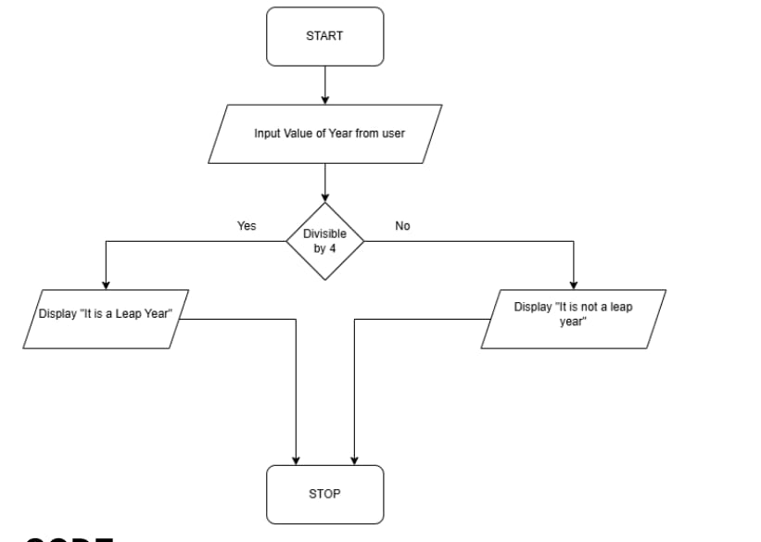
PLATFORM: Linux
CODE:
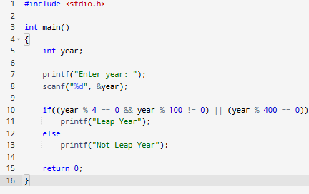

INPUT: Enter a year (integer value).

OUTPUT: Displays whether the entered year is a Leap Year or Not a Leap Year.
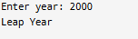
Sample Input
2024
Sample Output
2024 is a Leap Year
CONCLUSION: Thus, the program successfully checks whether a given year is a Leap Year using conditional statements in C.

FAQs:
- What is a leap year?
- Why is the year 1900 not a leap year but 2000 is?
- Which operators are used in this program?
- Difference between if and if–else statements.

